U3131909

Front End Wed Design

Assignment 3 Rationale

Table of Contents

Introduction 2

Design Inspiration 3

Approach 3

Breakdown steps 4

Design Decisions 5

Specifications 5

Challenges 5

WCAG Check: 6

Accessibility Audit 6

Conclusion 6

References 7

# Introduction

It is not surprising fact that technology, systems and programs alongside with their functionality, layout and design are changing rapidly. Whatever is trendy and innovative today, can be outdated tomorrow. Same situation happening with Web Design, quite often Web Designers apply their imagination and bringing it to the reality. Nowadays, the most relevant approach is Responsive Web Design which can be defined as easily adaptable to a different type of devices and multiple web browsers.

The aim of this project is to create a fully functional responsive website, with a given case scenario.

The main objectives are to create a responsive website using semantic HTML5 and CSS, complete a usability testing and create an accessibility audit, and refine identified Issues.

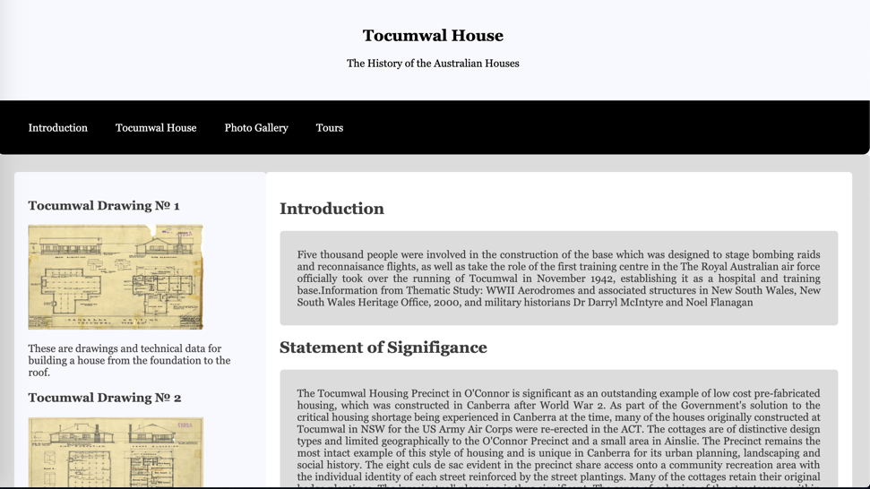

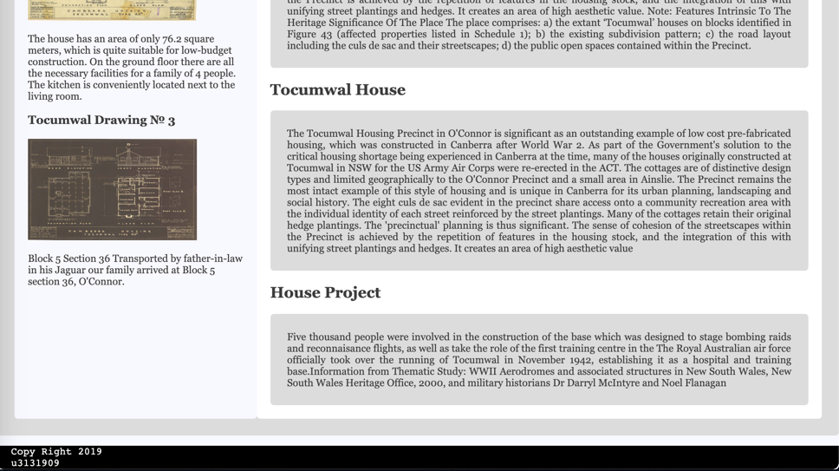

# Design Inspiration

Website is dedicated to one of the famous Australian heritage precincts the Tocumwal House. First approach in designing the website is to have simple and easy to digest structure. As there is importance in keeping historical value and content decision was made to focus on color inspiration in order to highlight the history of the building and its architecture without overwarming with bright and laud colours. Main focus was done on selecting appropriate color combination that will be suitable for all users including color-blind browsers. According to Collinge (2017) there are the color palette needs to be limited to two or three colors, use texture and patterns and avoid using bad color combinations, for example Green and Red, Green and Brown, Blue and Purple, Green and Blue, Light Green and Yellow, Blue and Grey, Green and Grey, Green and Black.

Color accessibility and simplicity in use is a key success in creating stylish and responsive website.

# Approach

Overall, this website was created in responsive and minimalistic design including minimum colors, simple grids and layouts, flexible images as the content is rich with historical facts, archived building plans and retrospective photographs.

Main page of the website includes a page title, introduction, statement of significance and beginning of the Tocumwal House article. On the left-hand side there is a small caption of how Tocumwal House was built from the foundation to the roof, by placing archived drawings and technical data of the building. The block of the navigation menu allocated in the top middle part of the page. The menu offers several hyperlinks that will help direct the user to the other pages on the site.

Second page contains continuation of the article with focus on some historical parts which separated by sections. At the bottom of the page there is a mini gallery which expands in next page to a large collection of photos.

Third page is a photo gallery and it is divided to a several groups, which represents a particular period and includes historical value of the Tocumwal House.

Last page of this website has information about all available tours with different options, for example group and group tours. Group tours can be held from five to thirty people. This page also provides tour description, time and location. Simply by providing First and Last Names, Address, Time and Type of the tour user can make an online booking.

Across the all pages of the website user can see at the end of the page is a footer block in which there is information about the ownership of the site. This assure security for the user to provide minimum personal information and on the same time will protect from Copy Right.

## Breakdown steps

|  |  |  |  |
| --- | --- | --- | --- |
| Header  Name of the Page |  |  |  |
| This is a Navigation bar  Introduction | Tocumwal House | Photo Gallery | Tour |
| left side  Image  Content | Main  Content |  |  |
|  | Footer  Footer of the page |  |  |

## Design Decisions

As it was mentioned earlier, in order to keep the website easy to use, responsive design to different browsers and devices, on the same time take into account accessibility for a range of users.

Three colors were selected for this project, which are Black, Light Grey and Orange on the White background. The choice of the colors was based on selecting safe colors for the background to be open and clear, font in Black as a habitual color for all users, sections including big amount of written information in Light Grey, as it is a neutral color which creates comfortable layer to avoid harsh contrast between White background and text in Black color. Additional Orange color was selected simply to highlight selected pages on the menu bar of the main page of the website, same as navigated areas such as photo and submit button highlighted in Orange to indicate selected choice. On the same time combination of Orange, Light Grey and Black on white canvas creates simple contrast and meet design rules.

Layout of the pages easy to navigate and it is simple to concentrate on written text as it is divided into smaller sections.

## Specifications

|  |  |
| --- | --- |
| **Navigation:** | **Responsive elements:** |

# Challenges

During the project there were identified several challenges. Some of the main issues were to meet WCAG compliance, select appropriate color combination, to make easy navigation through the website and to provide accessibility to it.

One of the main challenges is WCAG. Since the observance of all strict rules can greatly affect the style of the site, as well as reduce the convenience of the interface for the average user.

The second challenge is color adherence for people with color blindness, as these people do not tolerate many bright colors, and it was a rather interesting challenge. Since it was quite difficult to combine colors and present to a potential user.

## WCAG Check:

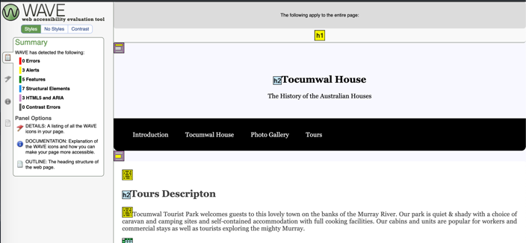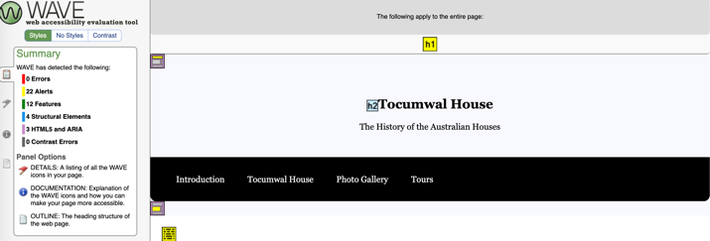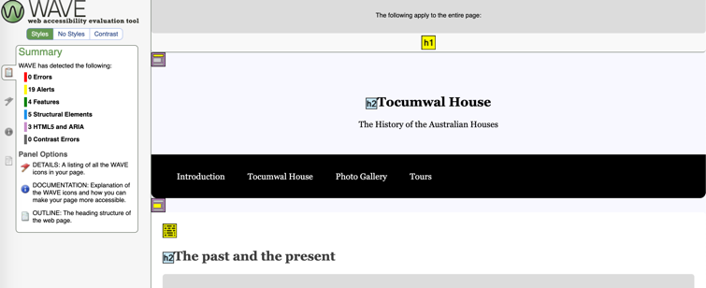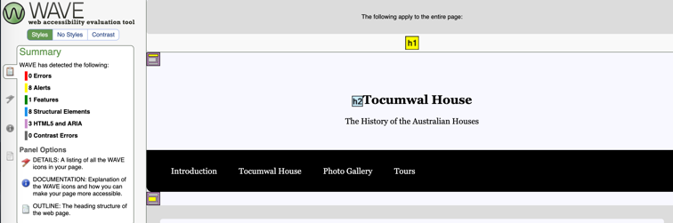

## Accessibility Audit

WCAG standards were applied during the creation of the website in order to meet every users’ expectations and needs. WCAG compliance focused on range of standards that provide easy access to the websites and overall use of internet to an extensive range of users of any disability.

# Conclusion

This website dedicated to Tocumwal House was created as a responsive website using semantic HTML5 and CSS. During creation there were completed a usability testing on the website and created an accessibility audit. There were also identified several challenges during the work that were resolved as a result.

# References

Robyn Collinge, R. (2017). *How to Design for Color Blindness* [Online]. Usabillablog [Accessed 2019]

University, S. (2019). *Web Design Project Rationale*. [online] Sfu.ca. Available at: http://www.sfu.ca/~afw3/courses/893/Documents/Assignments/SLWD%20Examples/PetrochemicalTrainingStaff.pdf [Accessed 10 May 2019].

Rationale, 1. (2019). *How to Write a Design Rationale - Jennifer Cederstam*. [online] Jennifer Cederstam. Available at: https://jennifercederstam.com/design-rationale/ [Accessed 10 May 2019].

Awwwards.com. (2019). *50 Examples of Responsive Web Design (plus 1)*. [online] Available at: https://www.awwwards.com/50-examples-of-responsive-web-design.html [Accessed 10 May 2019].

Webflow.com. (2019). *17 amazing sources of web design inspiration | Webflow Blog*. [online] Available at: https://webflow.com/blog/web-design-inspiration [Accessed 10 May 2019].

Usabilla Blog. (2019). *How to Design for Color Blindness*. [online] Available at: https://usabilla.com/blog/how-to-design-for-color-blindness/ [Accessed 10 May 2019].

Misha Moroshko, V. (2019). *Accessible Colors | WCAG 2.0 AA and AAA color contrast checker*. [online] Accessible-colors.com. Available at: http://accessible-colors.com/ [Accessed 10 May 2019].